Deployment Diagram

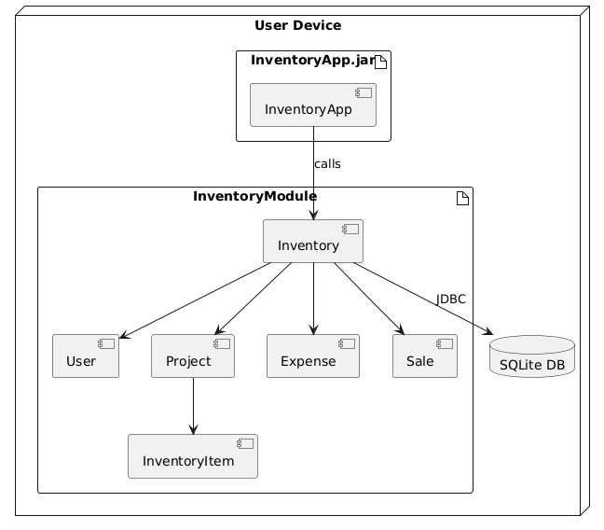

@startuml

node "User Device" {

artifact "InventoryApp.jar" {

[InventoryApp]

}

artifact "InventoryModule" {

[Inventory]

[User]

[Project]

[InventoryItem]

[Expense]

[Sale]

}

[InventoryApp] --> [Inventory] : calls

[Inventory] --> [User]

[Inventory] --> [Project]

[Project] --> [InventoryItem]

[Inventory] --> [Expense]

[Inventory] --> [Sale]

[Inventory] --> [SQLite DB] : JDBC

}

database "SQLite DB" {

}

@enduml